

**Parallel Programming**

**Homework 5**

Student Name : ABID ALI

Student ID : 2019380141

Student Email : [**abiduu354@gmail.com**](mailto:abiduu354@gmail.com) / [**3616990795@qq.com**](mailto:3616990795@qq.com)

Lecture : Professor Tianhai Zhao

Submission : 12/22/2022

Submitted Email : [zhaoth@nwpu.edu.cn](mailto:zhaoth@nwpu.edu.cn)

1. Try the codes in directories pi and hybrid.

**Solution:**

**Pi**

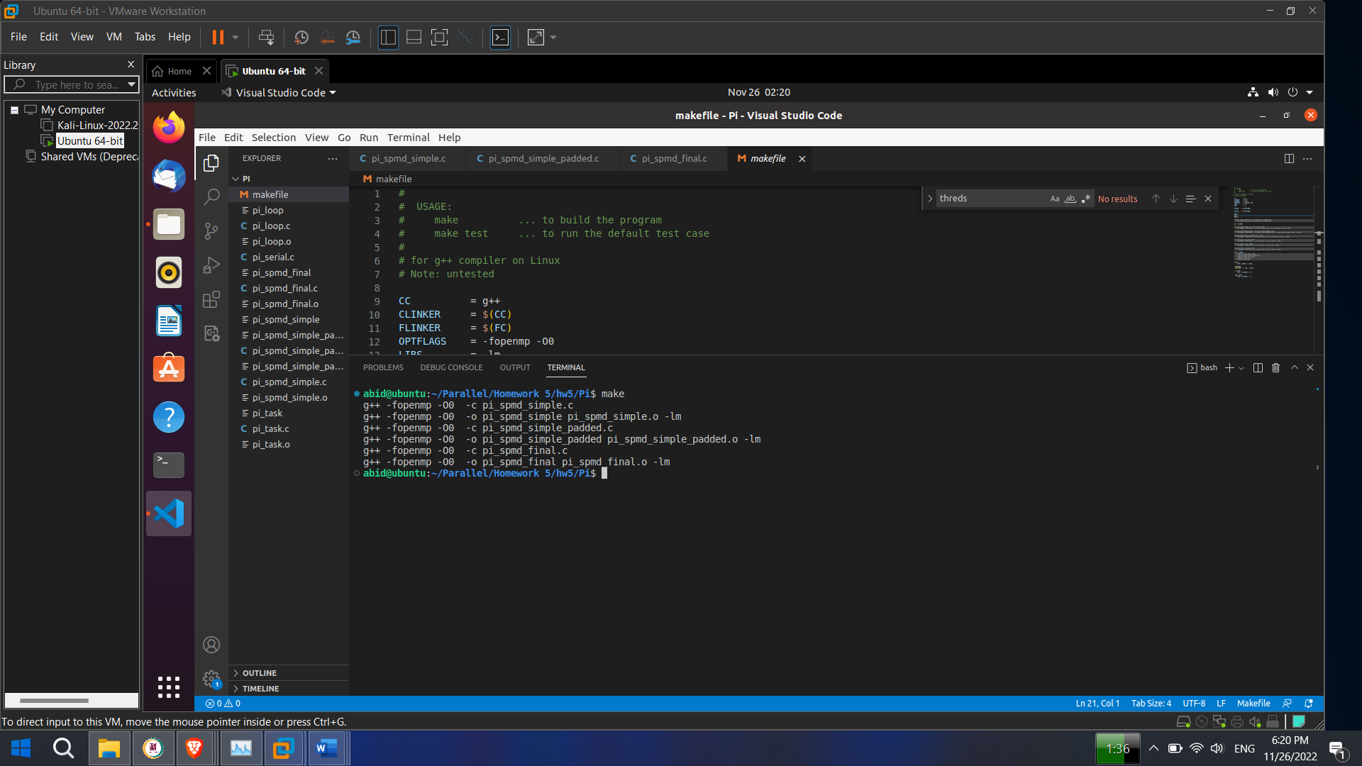

Fig : Make

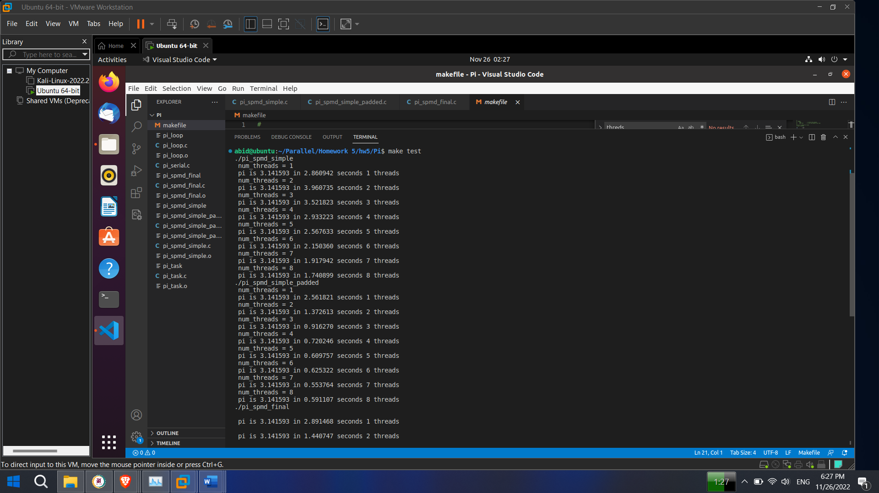

Fig : Make Test(1)

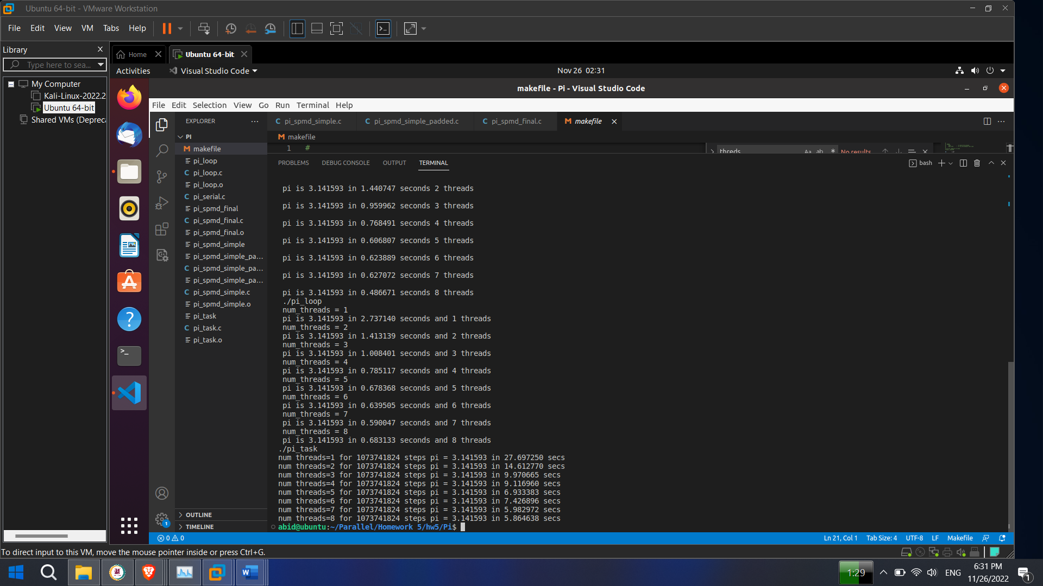

Fig : Make Test(2)

**Hybrid**

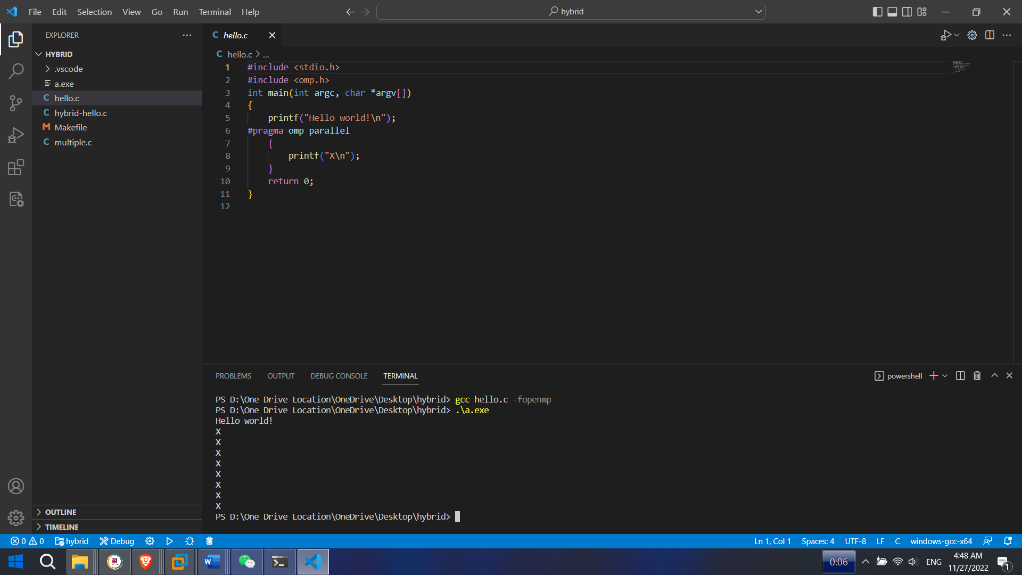

Fig : Hello.c

2. Implement the matrix multiplication program with OpenMP

you are to add OpenMP constructs to the sequential program for matrix multiplication given

here:

#include <omp.h>

#include <stdio.h>

#include <stdlib.h>

#define M 500

#define N 500

#define Max_threads 8

int main(int argc, char *argv) {

omp_set_num_threads(Max_threads);//set number of threads here

int i, j, k;

double sum;

double start, end; // used for timing

double **A, **B, **C;

A = malloc(M*sizeof(double *));

B = malloc(M*sizeof(double *));

C = malloc(M*sizeof(double *));

for (i = 0; i < M; i++) {

A[i] = malloc(N*sizeof(double));

B[i] = malloc(N*sizeof(double));

C[i] = malloc(N*sizeof(double));

}

//initialize matrix A, B, C

for (i = 0; i < M; i++) {

for (j = 0; j < N; j++) {

A[i][j] = j*1;

B[i][j] = i*j+2;

C[i][j] = j-i*2;

}

}

start = omp_get_wtime(); //start time measurement

for (i = 0; i < M; i++) {

for (j = 0; j < N; j++) {

sum = 0;

for (k=0; k < M; k++) {

sum += A[i][k]*B[k][j];

}

C[i][j] = sum;

}

}

end = omp_get_wtime(); //end time measurement

printf("Time of computation: %f\n", end-start);

}

1. Add the necessary pragma to parallelize the outer for loop;

**Theory:**

Typically, we want to parallelize the outermost loop that makes sense. If we parallelize the inner loops, we will be introducing extra overhead. By having the "loop bodies" be as large as possible, we will get better overall throughput. This really boils down to Amdahl's law - in this case, the overhead involved in scheduling the parallel work items is not parallelizable, so the more of that work you do, the lower the potential efficiency overall.

The risk is that, if there are too few items in the outer loop, you may end up where work items can't be run in parallel, since there will be a point where there are fewer items than processing cores in your system.

Provided that our outer loop has enough to keep the cores busy, it's the best place to go - especially if the amount of work done in each loop body is relatively consistent.

**Solution:**

start = omp_get_wtime();

#pragma omp parallel for

//#pragma omp parallel for collapse(2)

for (i = 0; i < M; i++)

{

for (j = 0; j < N; j++)

{

sum = 0;

#pragma omp parallel for

for (k=0; k < M; k++)

{

sum += A[i][k]*B[k][j];

}

C[i][j] = sum;

}

}

end = omp_get_wtime();

**Result:**

1st time time we got 1.466427

2nd time time we got 1.351925

3rd time time we got 1.642867

4th time time we got 1.827936

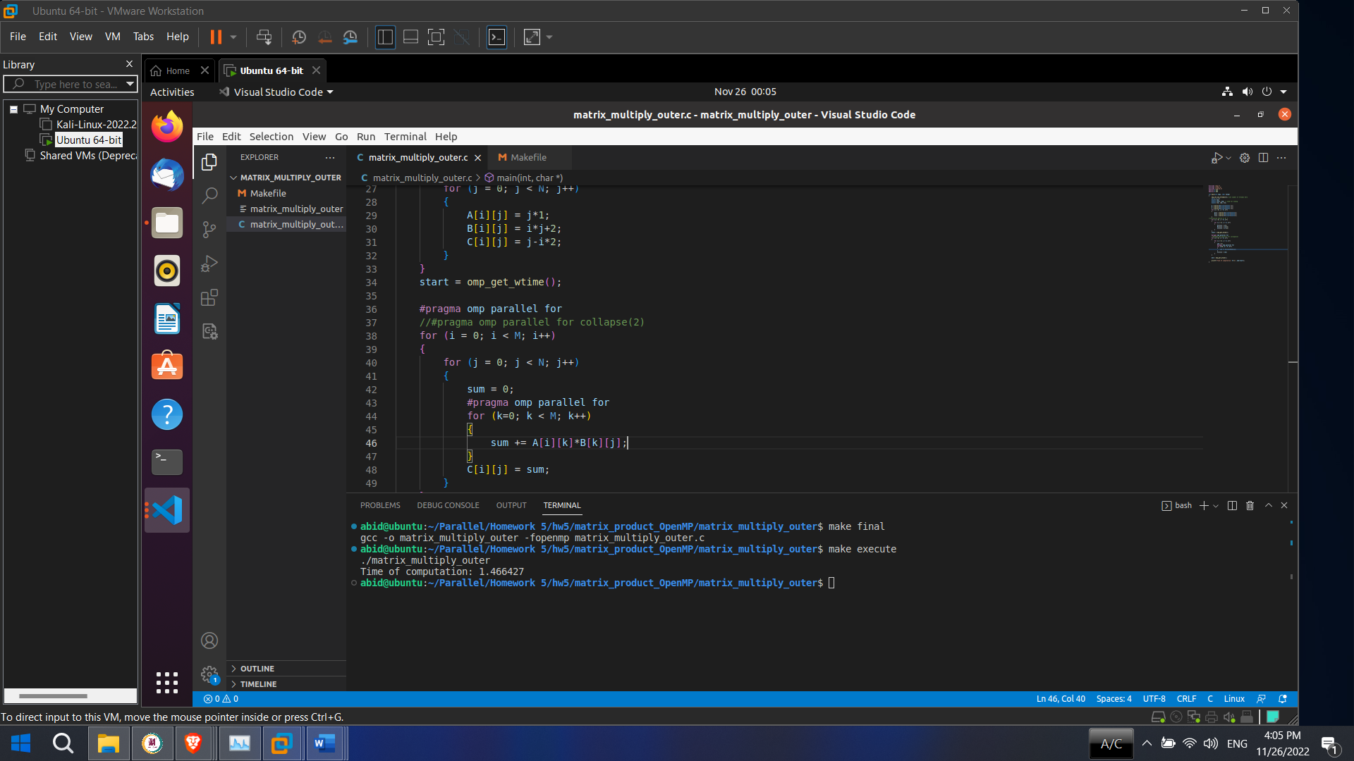

1. Remove the pragma for the outer for loop and create a pragma for the middle for loop;

**Solution:**

start = omp_get_wtime();

for (i = 0; i < M; i++)

{

#pragma omp parallel for

for (j = 0; j < N; j++)

{

sum = 0;

#pragma omp parallel for

for (k=0; k < M; k++)

{

sum += A[i][k]*B[k][j];

}

C[i][j] = sum;

}

}

end = omp_get_wtime();

**Result:**

1st time time we got 1.500284

2nd time time we got 1.896121

3rd time time we got 2.022340

4th time time we got 2.365350

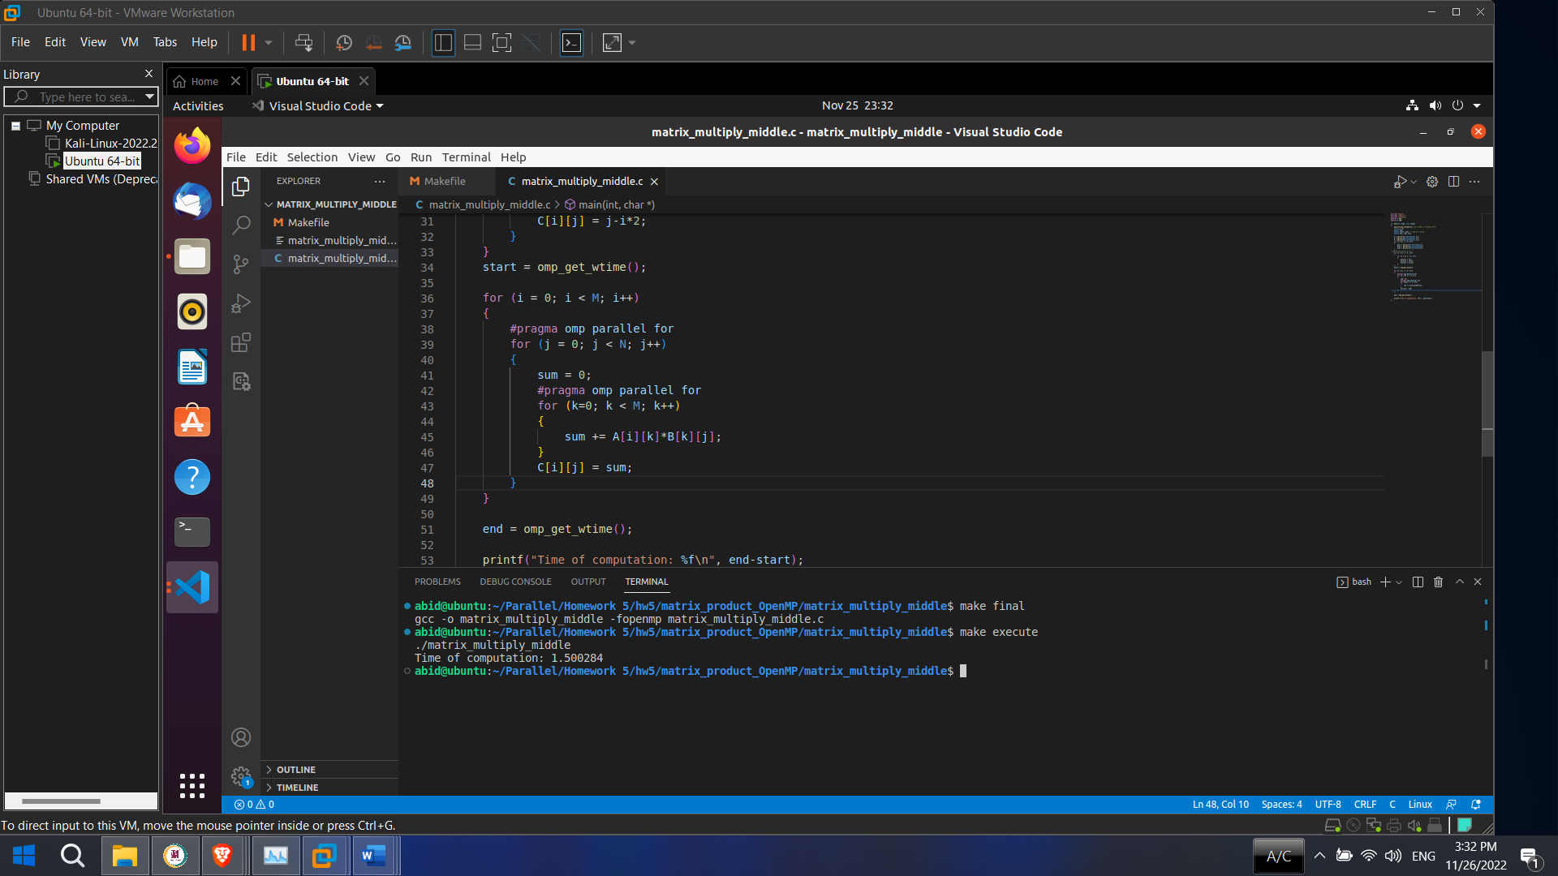

1. Add the necessary pragma’s to parallelize both the outer and middle for loops.

**Solution:**

start = omp_get_wtime();

#pragma omp parallel for

for (i = 0; i < M; i++)

{

#pragma omp parallel for

for (j = 0; j < N; j++)

{

sum = 0;

#pragma omp parallel for

for (k=0; k < M; k++)

{

sum += A[i][k]*B[k][j];

}

C[i][j] = sum;

}

}

end = omp_get_wtime();

**Result:**

1st time time we got 1.407169

2nd time time we got 1.411372

3rd time time we got 1.488176

4th time time we got 1.536947

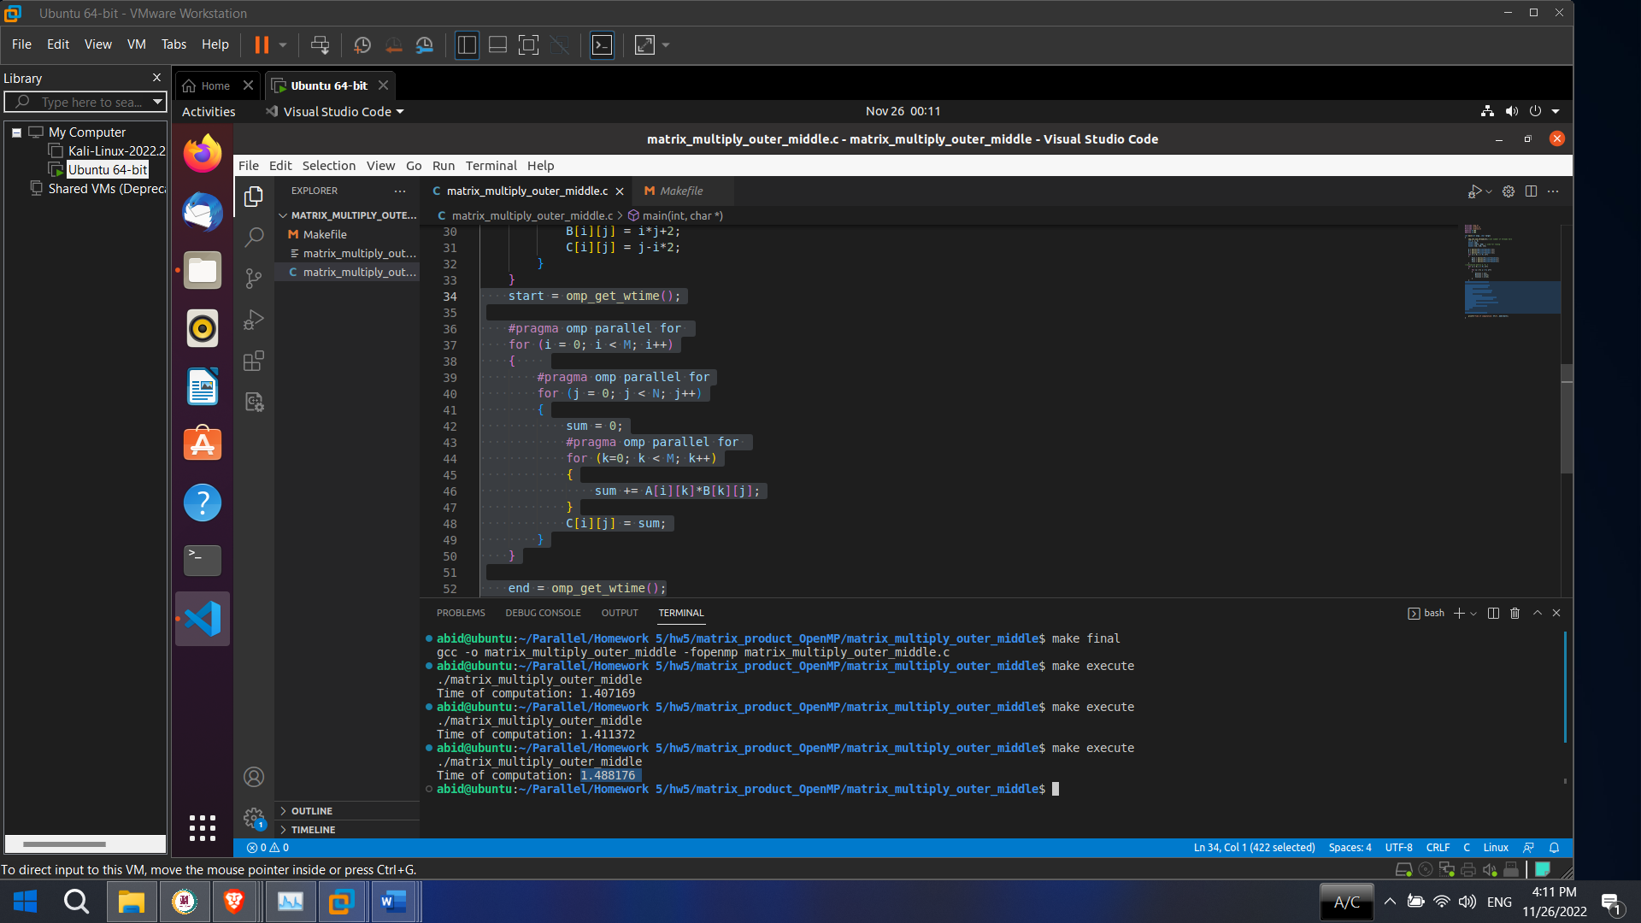

1. Add an assert function that compares the parallel computing result with serial computing result in order to make sure that you get correct result.

You need to collect timing data given one thread, four threads, eight threads, and 16 threads and two matrix sizes, 50x50 and 500x500. You will find that when you run the same program several times, the timing values can vary significantly. Therefore, for each set of conditions, collect ten data values and average them. You should write a report and analyze the results.

Here are the conditions you should collect data for:

1. No parallelization at all (that is, the given program)

**Solution:**

**Code**

#include <omp.h>

#include <stdio.h>

#include <stdlib.h>

// Set two matrix sizes 500x500 and 50x50

#define M 500

#define N 500

// Threads set to 1,4,8,16

#define Max_threads 8

int main(int argc, char *argv) {

omp_set_num_threads(Max_threads);//set number of threads here

int i, j, k;

double sum;

double start, end; // used for timing

double **A, **B, **C;

/* FILE *fp; C provides a number of build-in function to perform basic file operations:

fopen() - create a new file or open a existing file.

fclose() - close a file */

FILE *fp; // Create file pointers.

A = malloc(M*sizeof(double *));

B = malloc(M*sizeof(double *));

C = malloc(M*sizeof(double *));

/* After a call to freopen, it associates STDOUT to file file.txt, so whatever we write at STDOUT that goes inside file.txt */

fp = freopen("file.txt", "w+", stdout);

for (i = 0; i < M; i++) {

A[i] = malloc(N*sizeof(double));

B[i] = malloc(N*sizeof(double));

C[i] = malloc(N*sizeof(double));

}

//initialize matrix A, B, C

for (i = 0; i < M; i++) {

for (j = 0; j < N; j++) {

A[i][j] = j*1;

B[i][j] = i*j+2;

C[i][j] = j-i*2;

}

}

start = omp_get_wtime(); //start time measurement

for (i = 0; i < M; i++) {

for (j = 0; j < N; j++) {

sum = 0;

for (k=0; k < M; k++) {

sum += A[i][k]*B[k][j];

}

C[i][j] = sum;

}

}

end = omp_get_wtime(); //end time measurement

printf("Time of computation: %f\n", end-start);

// Closing the file using fclose() function.

fclose(fp);

}

**Result**

**1 threads and two matrix sizes 500x500**

#define M 500

#define N 500

#define Max_threads 1

omp_set_num_threads(Max_threads)

Time of computation: 0.594810

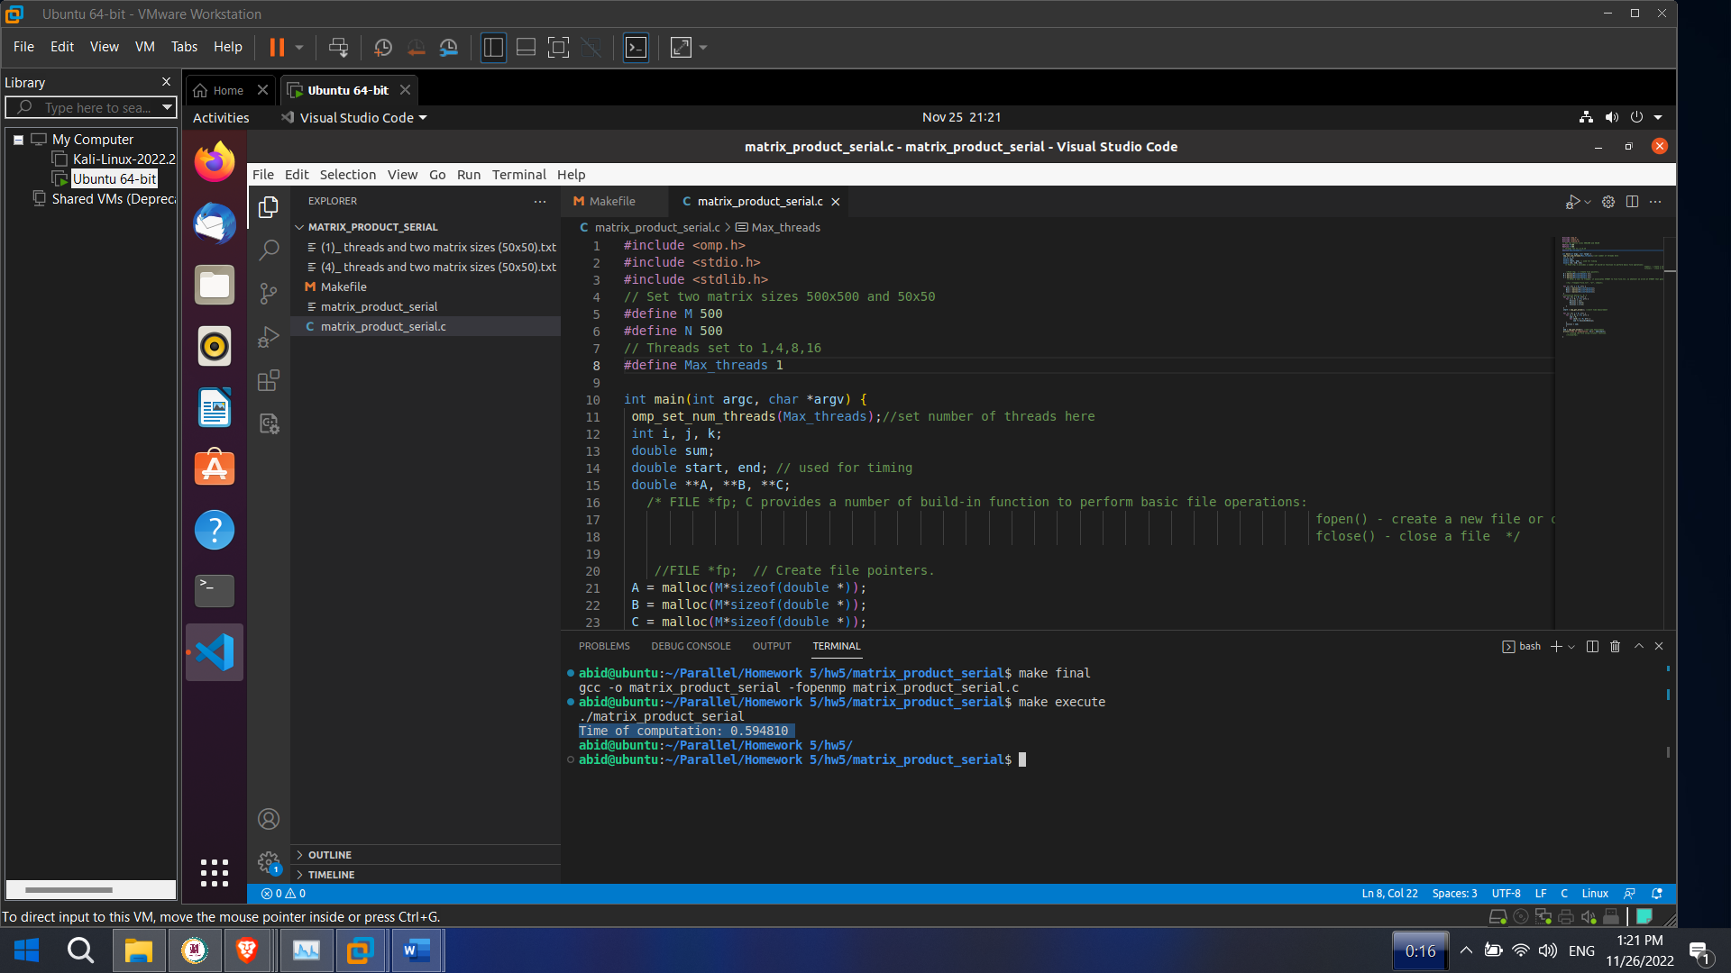

Fig : 1 threads and two matrix sizes 500x500

**Result**

**4 threads and two matrix sizes 500x500**

#define M 500

#define N 500

#define Max_threads 4

omp_set_num_threads(Max_threads)

Time of computation: 0.475611

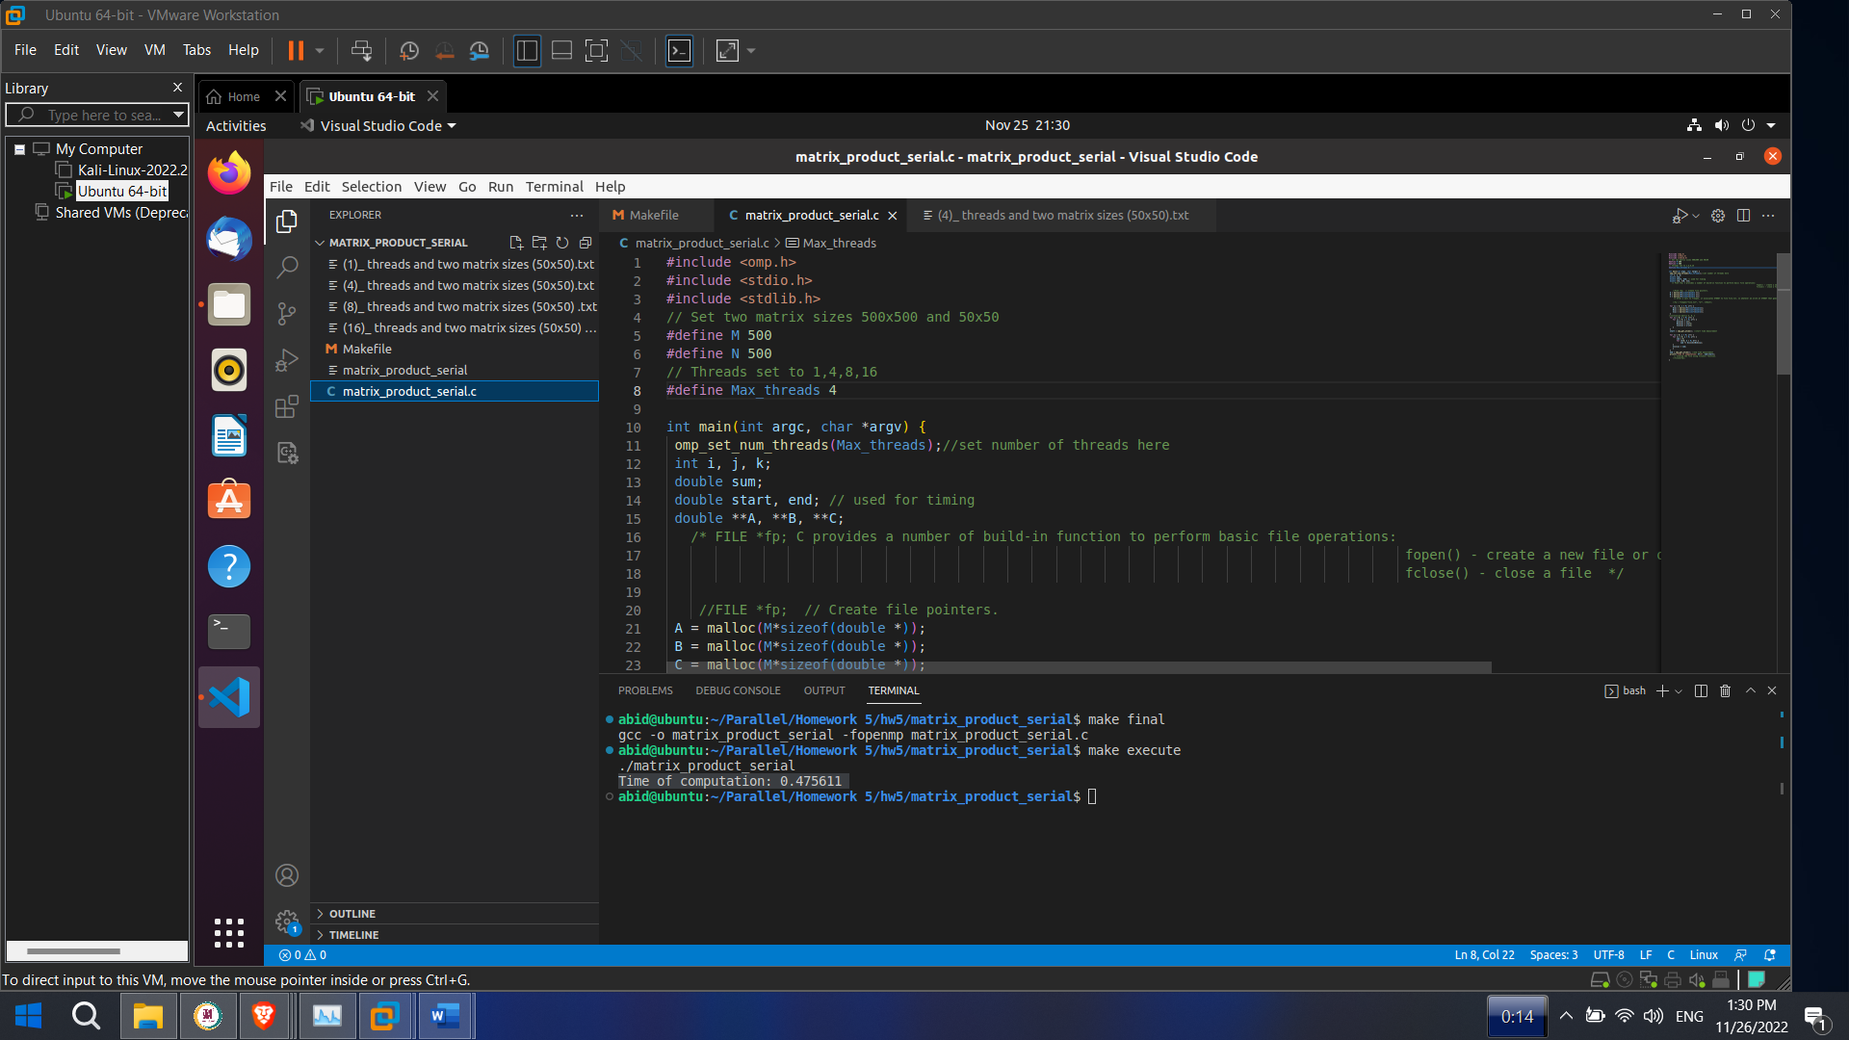

Fig : 4 threads and two matrix sizes 500x500

**Result**

**8 threads and two matrix sizes 500x500**

#define M 500

#define N 500

#define Max_threads 8

omp_set_num_threads(Max_threads)

Time of computation: 0.577183

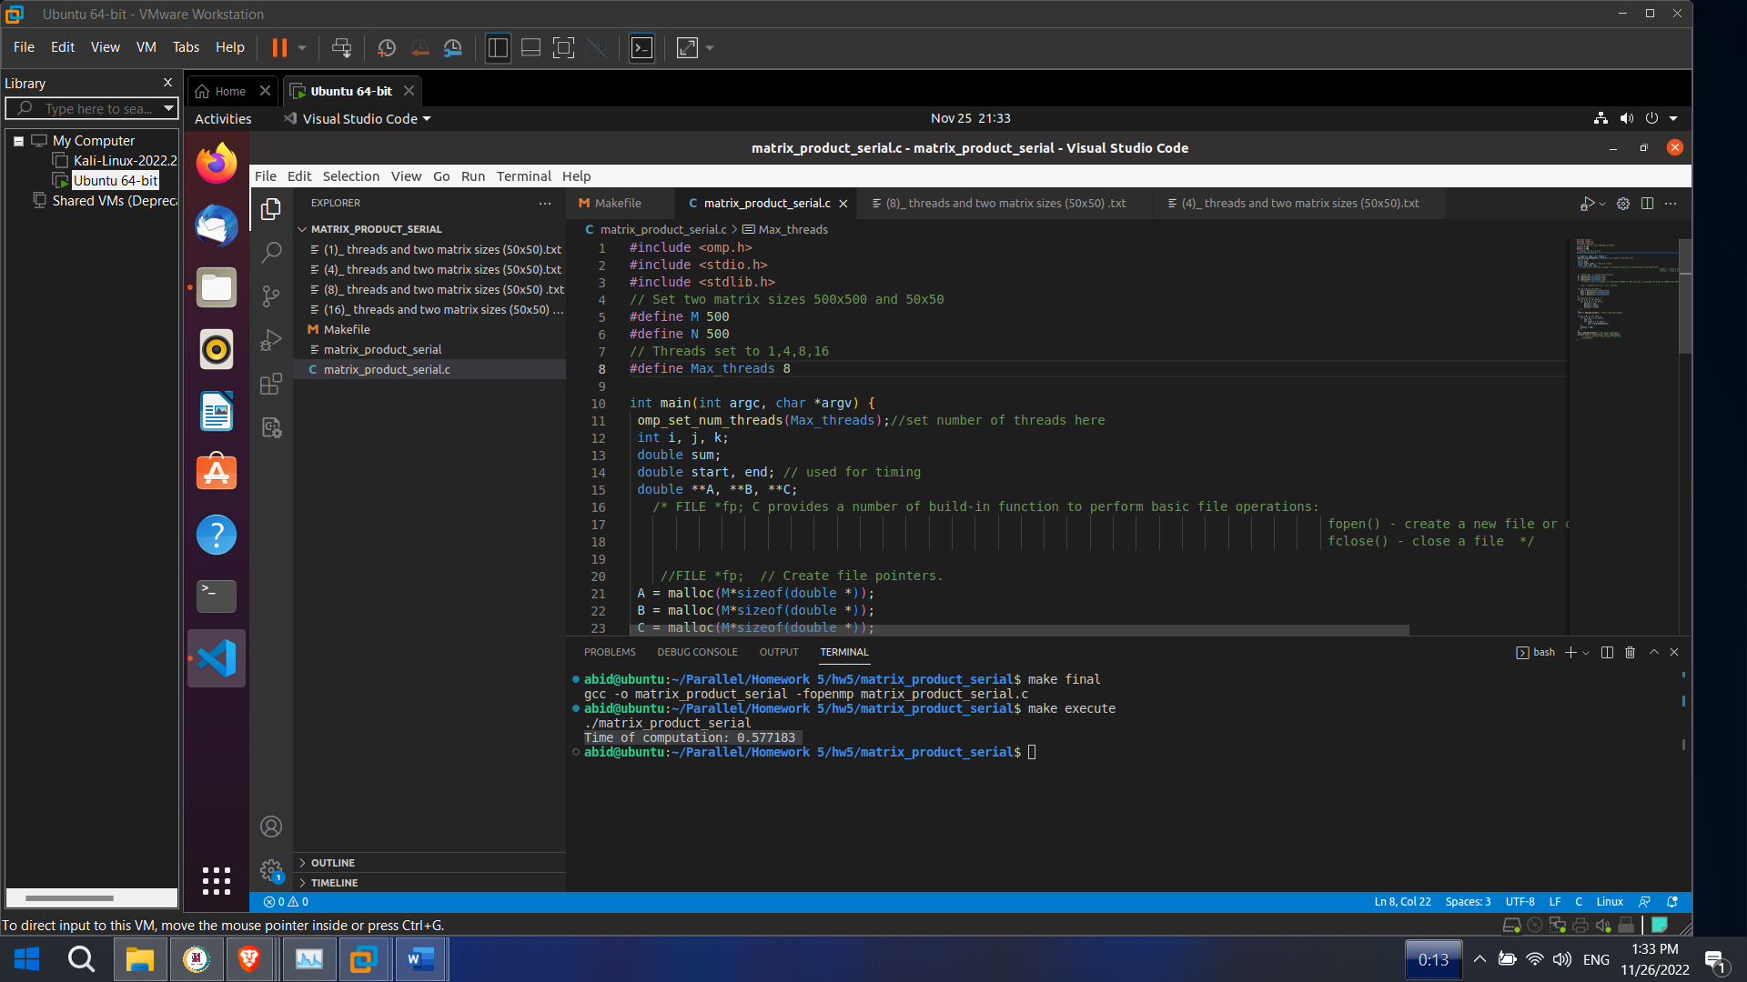

Fig : 8 threads and two matrix sizes 50x50

**Result**

**16 threads and two matrix sizes 500x500**

#define M 500

#define N 500

#define Max_threads 16

omp_set_num_threads(Max_threads)

Time of computation: 0.578601

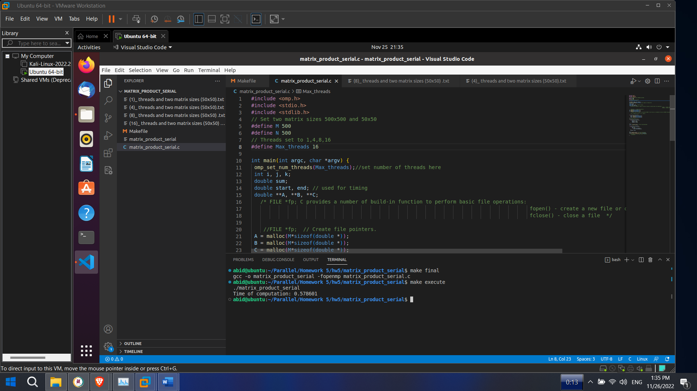

Fig : 16 threads and two matrix sizes 500x500

**1 threads and two matrix sizes 50x50**

#define M 50

#define N 50

#define Max_threads 1

omp_set_num_threads(Max_threads)

Time of computation: 0.001033

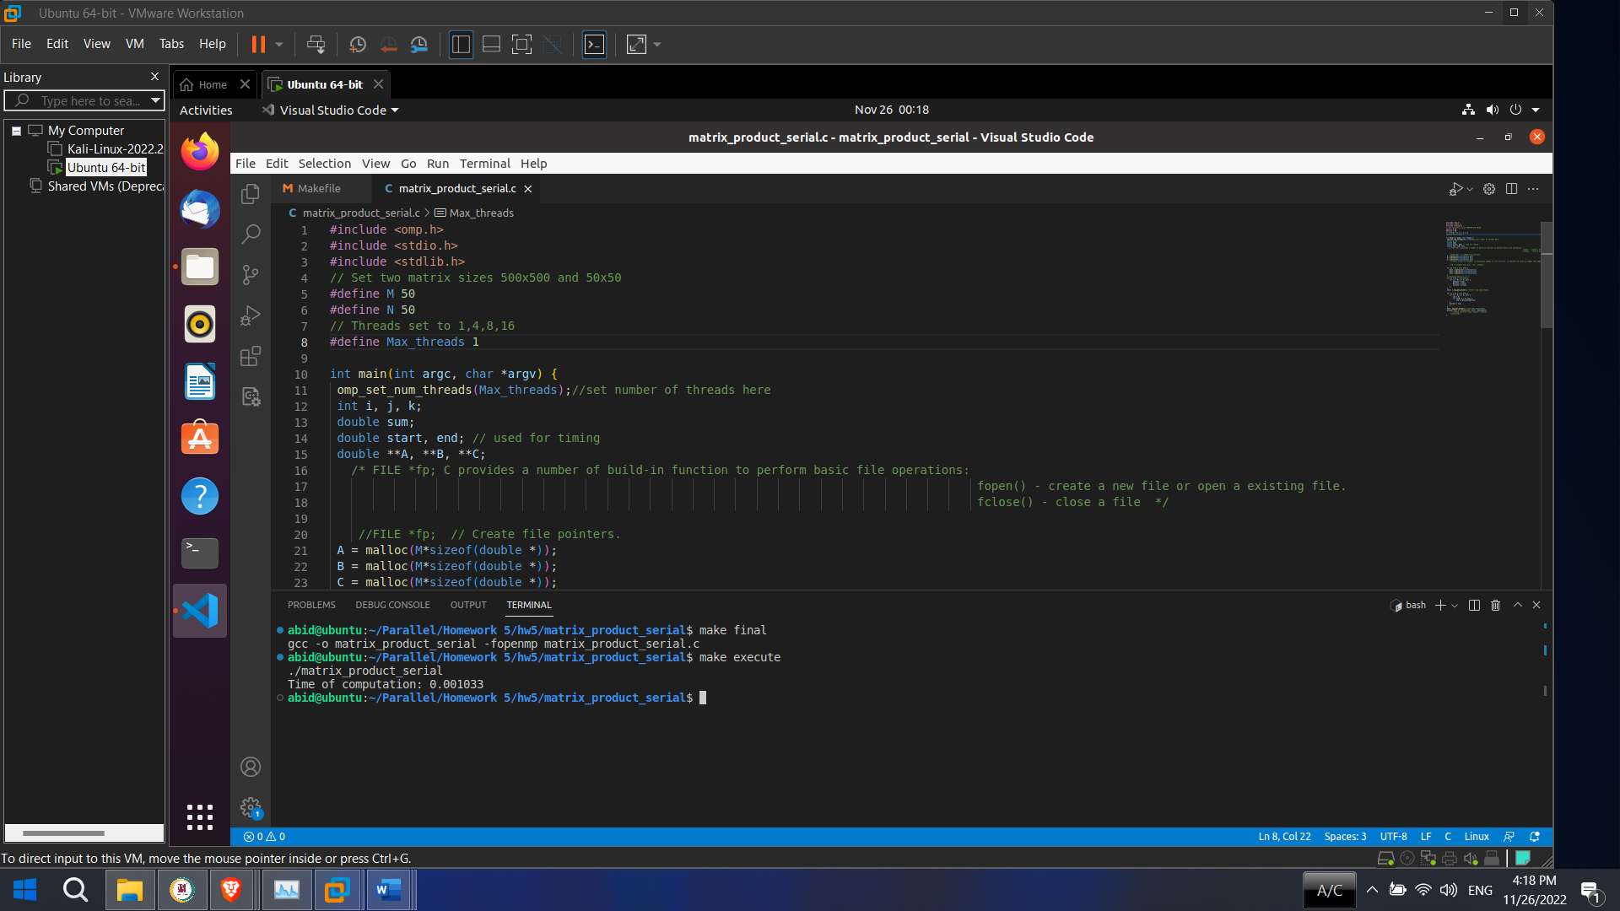

Fig : 1 threads and two matrix sizes 50x50

**4 threads and two matrix sizes 50x50**

#define M 50

#define N 50

#define Max_threads 4

omp_set_num_threads(Max_threads)

Time of computation: 0.001341

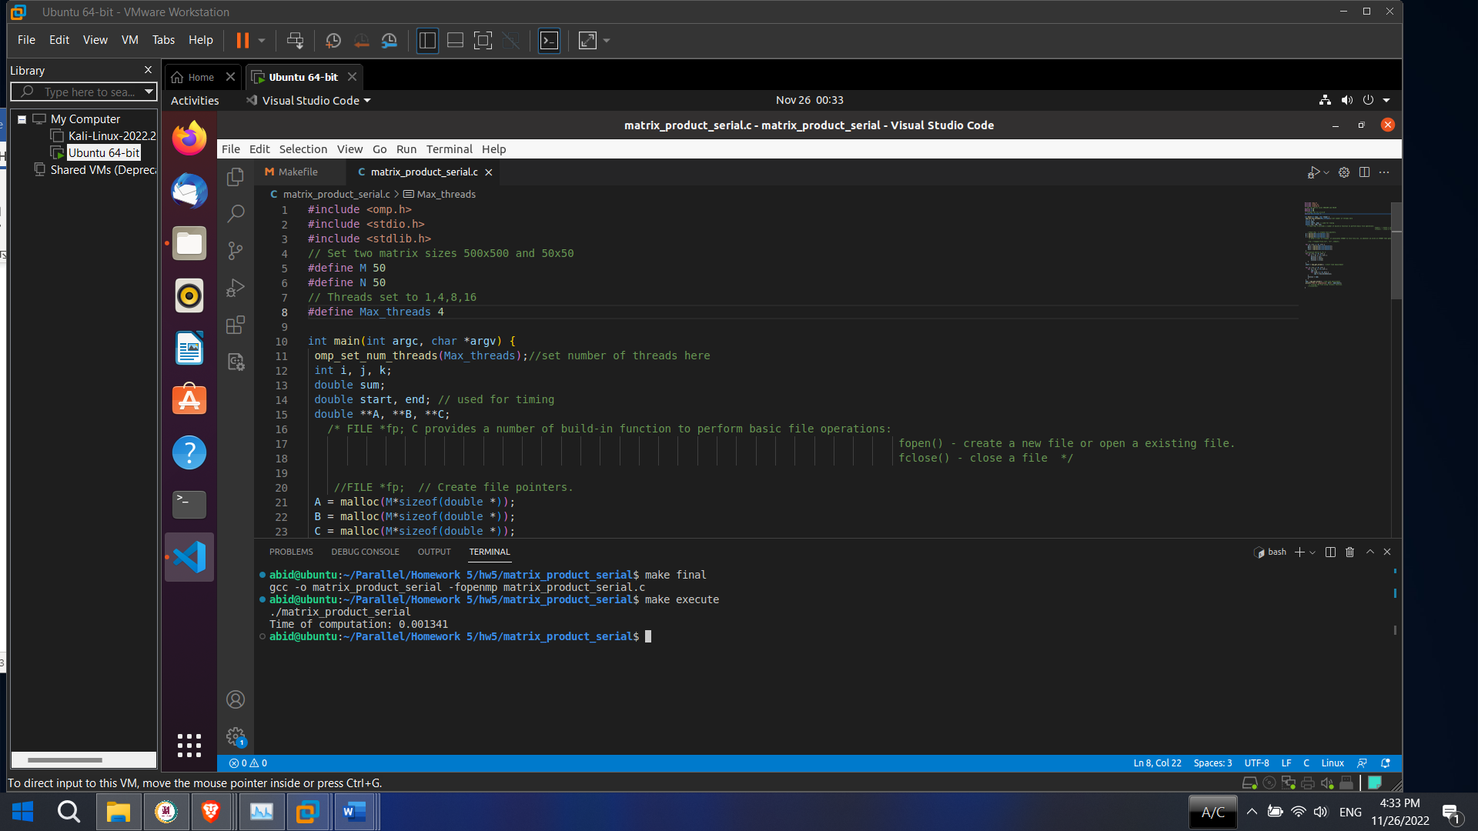

Fig : 4 threads and two matrix sizes 50x50

**8 threads and two matrix sizes 50x50**

#define M 50

#define N 50

#define Max_threads 8

omp_set_num_threads(Max_threads)

Time of computation: 0.001732

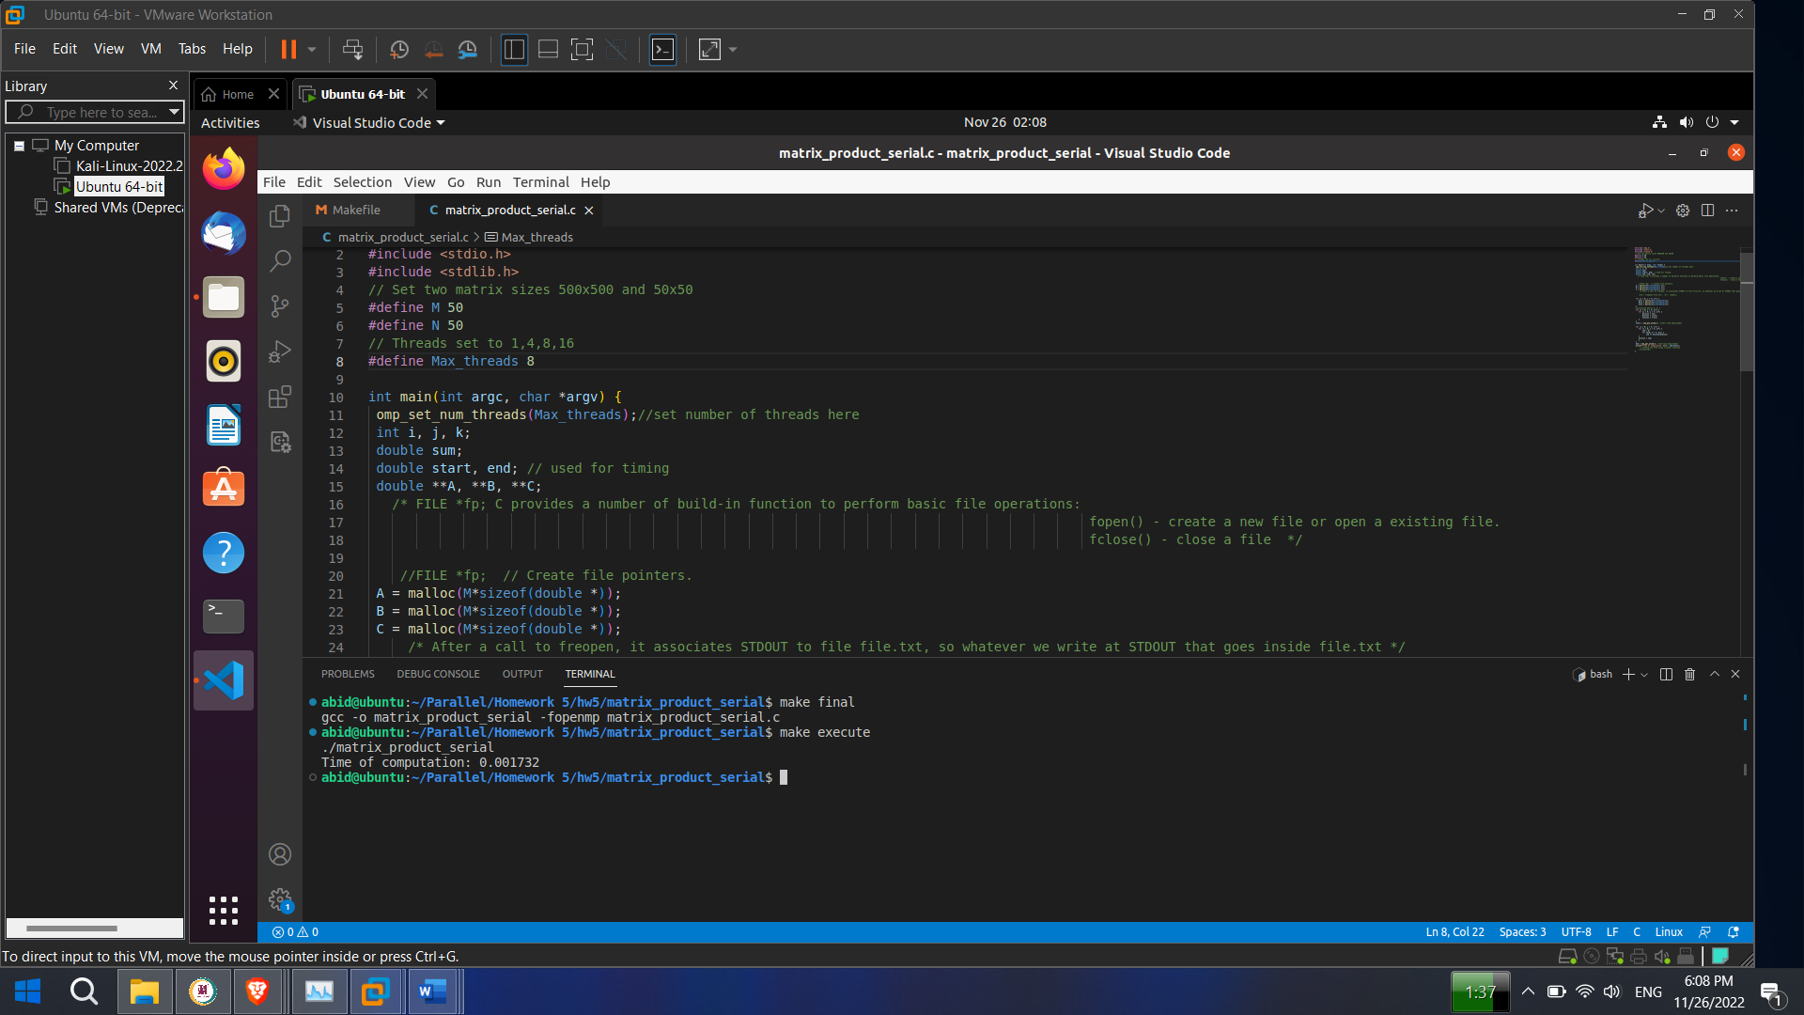

Fig : 8 threads and two matrix sizes 50x50

**16 threads and two matrix sizes 50x50**

#define M 50

#define N 50

#define Max_threads 16

omp_set_num_threads(Max_threads)

Time of computation: 0.001313

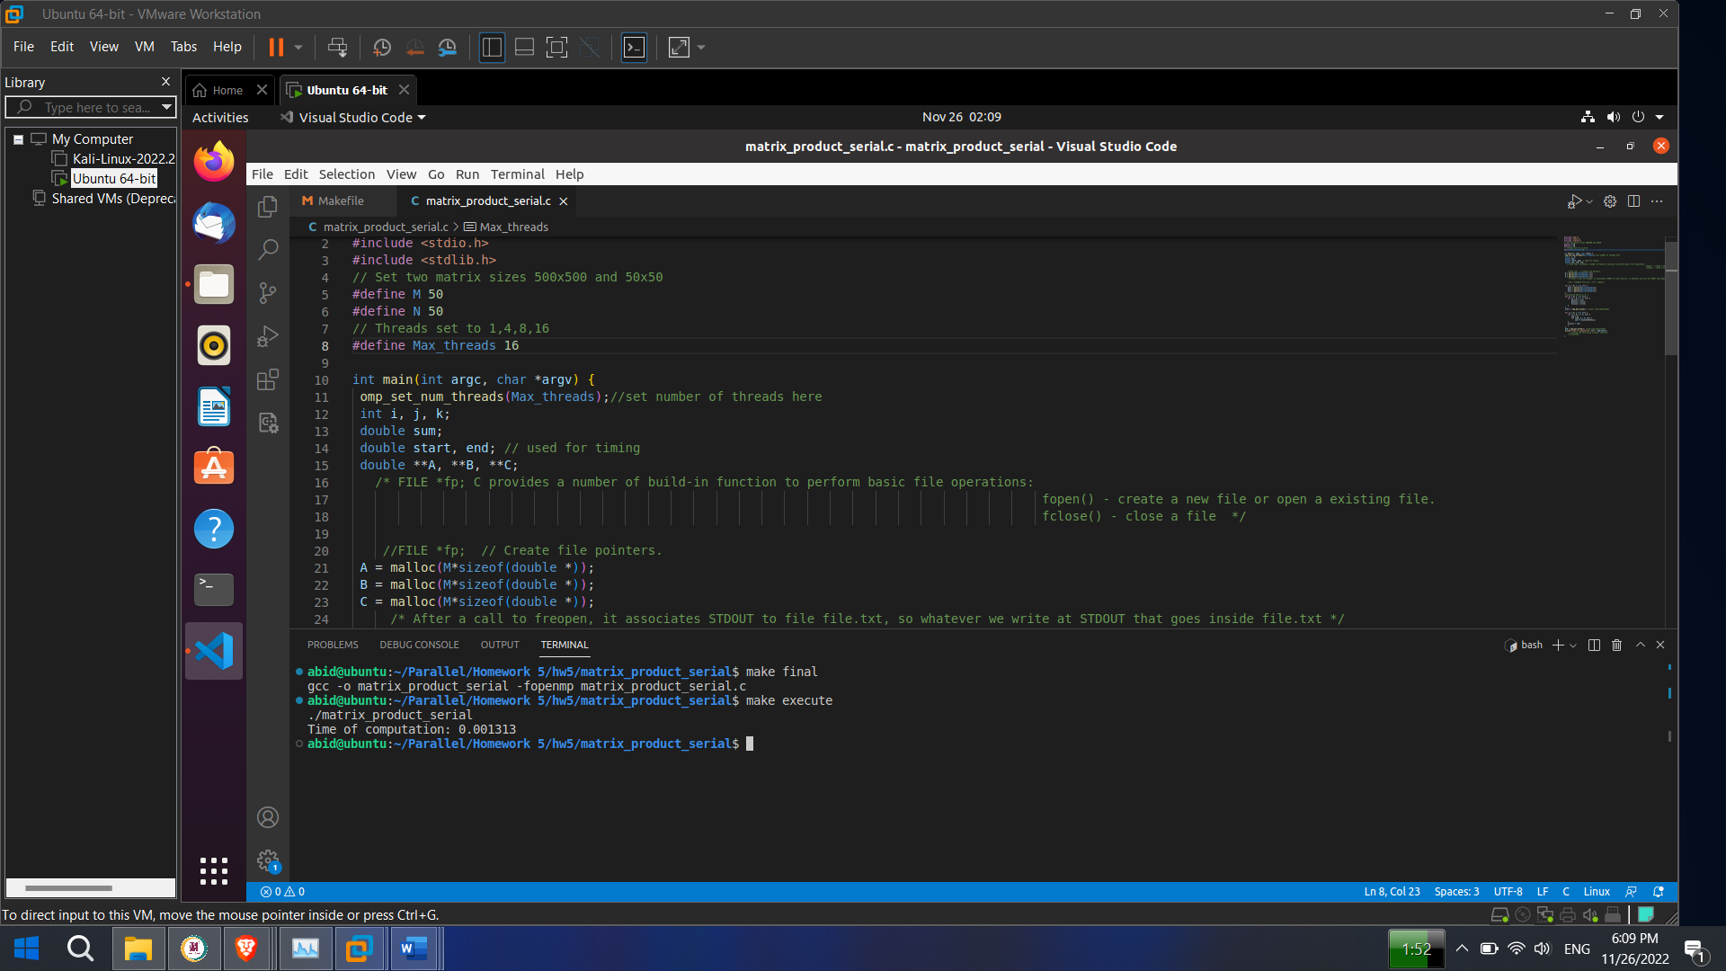

Fig : 16 threads and two matrix sizes 50x50

1. Parallelizing the loops as above with 1, 4, 8, and 16 threads using matrix sizes 50x50 and 500x500

**Solution:**

**Code**

#include <stdio.h>

#include <stdlib.h>

#include <omp.h>

// Set two matrix sizes 500x500 and 50x50

#define M 500

#define N 500

int main(int argc, char *argv)

{

//set number of threads here.That is 1,4,8,16

omp_set_num_threads(8);

int i,j,k;

double sum;

double start, end, start_p, end_p;

double **A, **B, **C;

/* FILE *fp; C provides a number of build-in function to perform basic file operations:

fopen() - create a new file or open a existing file.

fclose() - close a file */

FILE *fp; // Create file pointers.

A= malloc(M*sizeof(double *));

B= malloc(M*sizeof(double *));

C= malloc(M*sizeof(double *));

/* After a call to freopen, it associates STDOUT to file file.txt, so whatever we write at STDOUT that goes inside file.txt */

fp = freopen("file.txt", "w+", stdout);

for(i=0; i<M; i++)

{

A[i]= malloc(N*sizeof(double));

B[i]= malloc(N*sizeof(double));

C[i]= malloc(N*sizeof(double));

}

//initialize matrix A, B, C

for(i=0; i<M; i++)

{

for(j=0; j<N; j++)

{

A[i][j]=j*1;

B[i][j]=i*j+2;

C[i][j]=j-i*2;

}

}

printf("MATRIX A:\n");

for(i=0; i<M; i++)

{

for(j=0; j<N; j++)

{

printf("%f ",A[i][j]);

}

printf("\n");

}

printf("\n");

printf("MATRIX B:\n");

for(i=0; i<M; i++)

{

for(j=0; j<N; j++)

{

printf("%f ",B[i][j]);

}

printf("\n");

}

printf("\n");

start= omp_get_wtime(); //start time measurement

for(i=0; i<M; i++)

{

for(j=0; j<N; j++)

{

sum=0;

for(k=0; k<M; k++)

{

sum+=A[i][k]*B[k][j];

}

C[i][j]=sum;

}

}

end= omp_get_wtime();

printf("Serial Execution Time: %f\n\n",(end-start));

//////////////////////////////////

start_p= omp_get_wtime();

#pragma omp parallel for

for(i=0; i<M; i++)

{

for(j=0; j<N; j++)

{

sum=0;

for(k=0; k<M; k++)

{

sum+=A[i][k]*B[k][j];

}

C[i][j]=sum;

}

}

end_p= omp_get_wtime(); //end time measurement

printf("Parallel Execution Time: %f\n\n",(end_p-start_p));

printf("MATRIX MULTIPLICATION, MATRIX C:\n");

for(i=0; i<M; i++)

{

for(j=0; j<N; j++)

{

printf("%f ",C[i][j]);

}

printf("\n");

}

// Closing the file using fclose() function.

fclose(fp);

return 0;

}

**Result**

**1 threads and two matrix sizes 500x500**

#define M 500

#define N 500

omp_set_num_threads(1);



Serial Execution Time: 1.500378

Parallel Execution Time: 2.339876

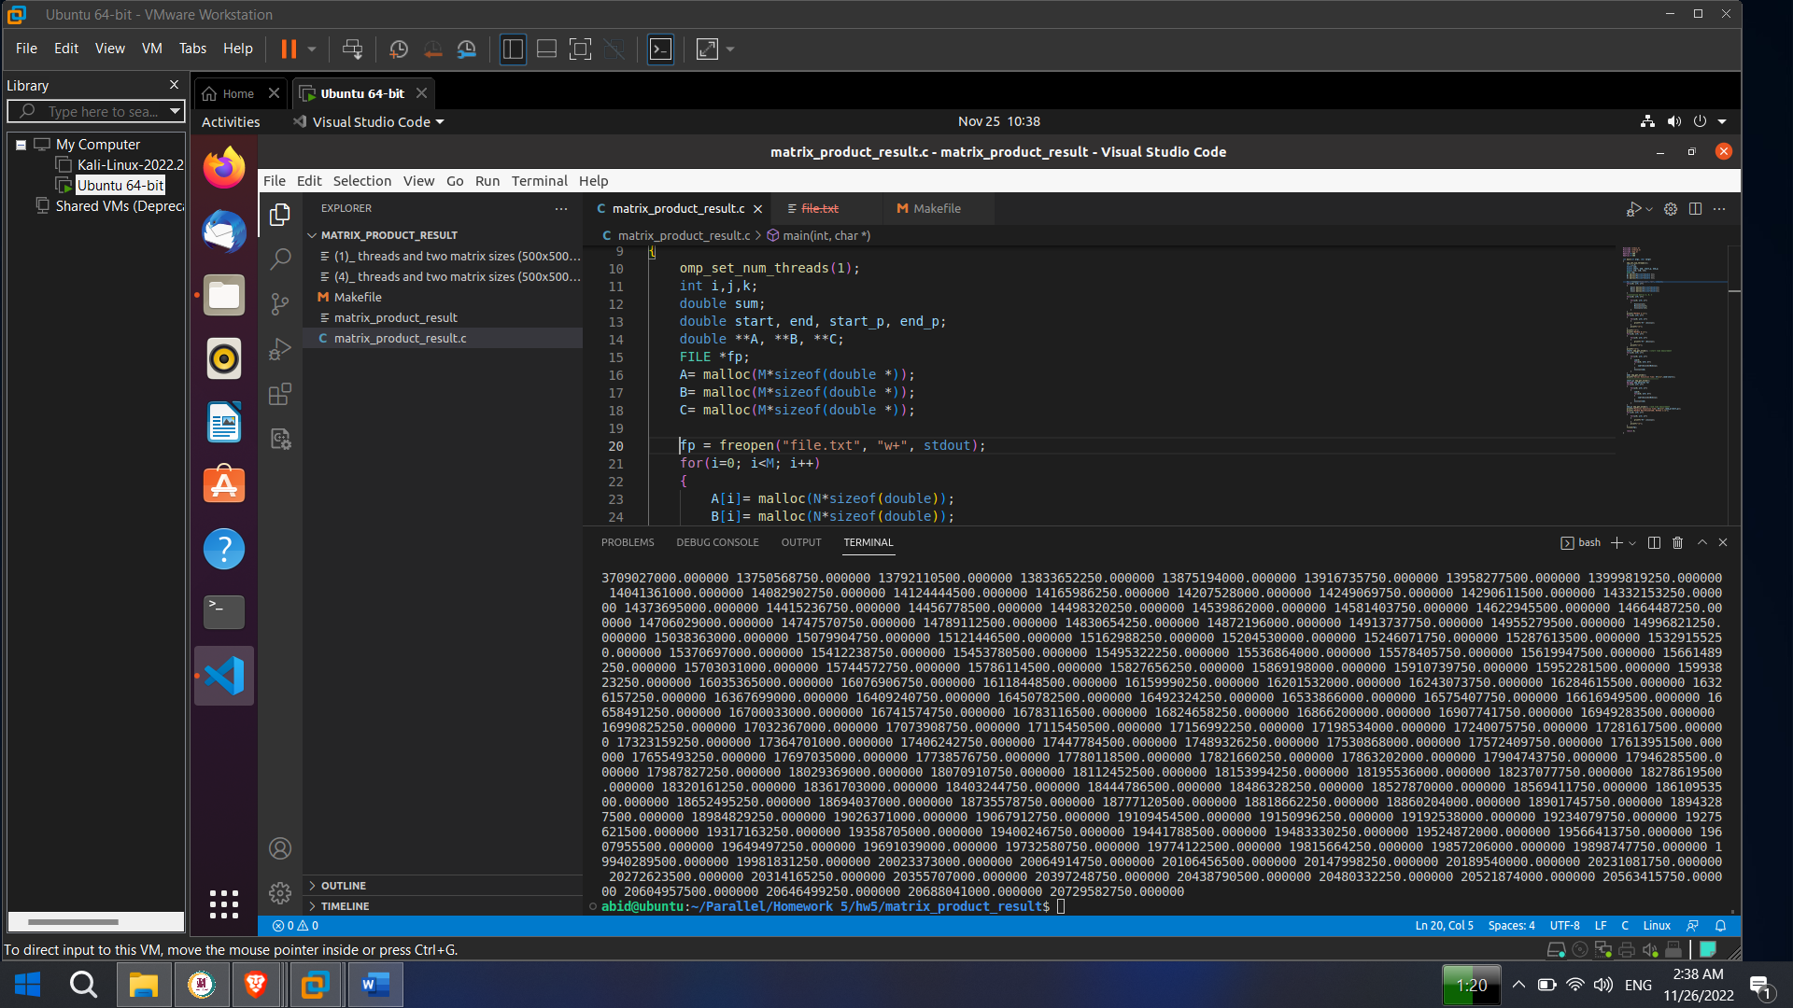

Fig : 1 threads and two matrix sizes 500x500

**Result**

**4 threads and two matrix sizes 500x500**

#define M 500

#define N 500

omp_set_num_threads(4);



Serial Execution Time: 0.047728

Parallel Execution Time: Didn’t get due to segmentation fault. Don’t know the exact reason why the parallel part function couldn’t get the value.I think there is a limitation of processor and core that could be the reason.

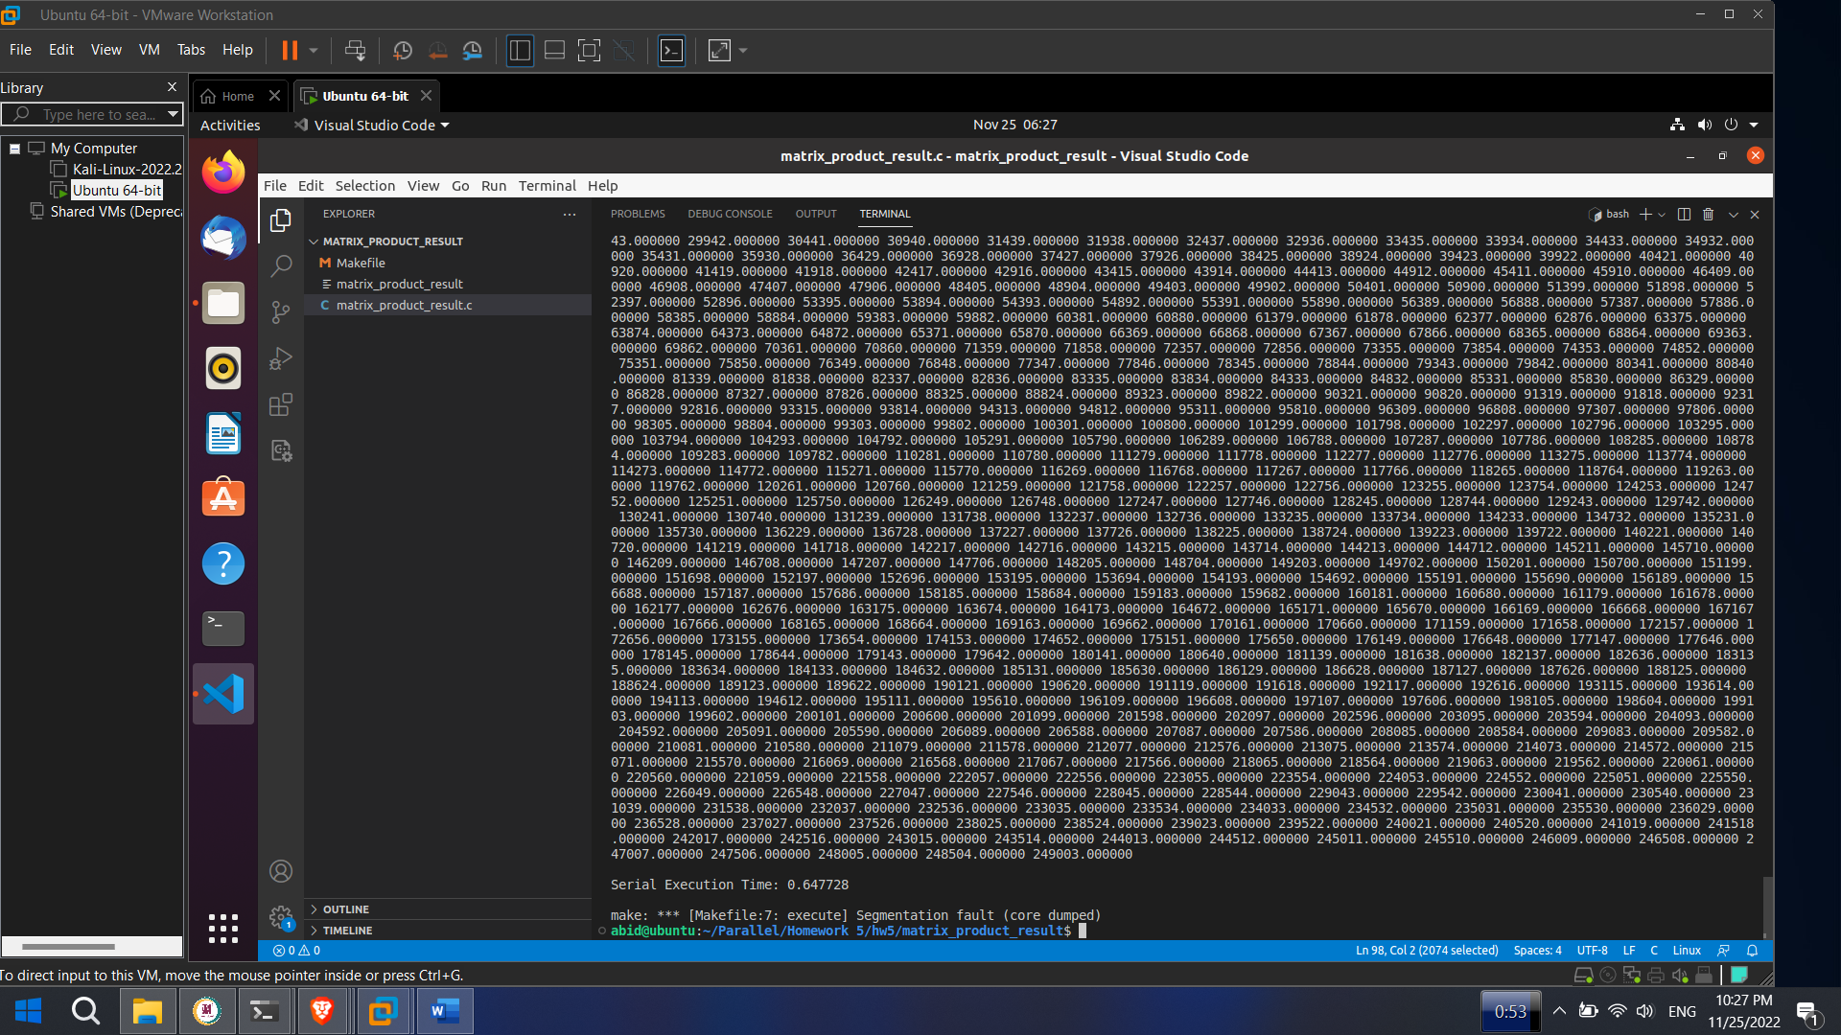

Fig : 4 threads and two matrix sizes 500x500

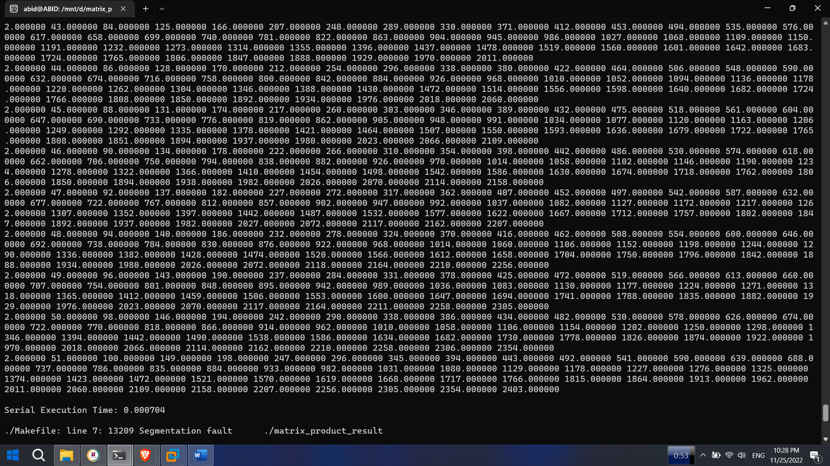

Fig (Extra) : 4 threads and two matrix sizes, 500x500

**8 threads and two matrix sizes 500x500**

#define M 500

#define N 500

omp_set_num_threads(8);



Serial Execution Time: 3.235702

Parallel Execution Time: Didn’t get due to segmentation fault. Don’t know the exact reason why the parallel part function couldn’t get the value.I think there is a limitation of processor and core that could be the reason.

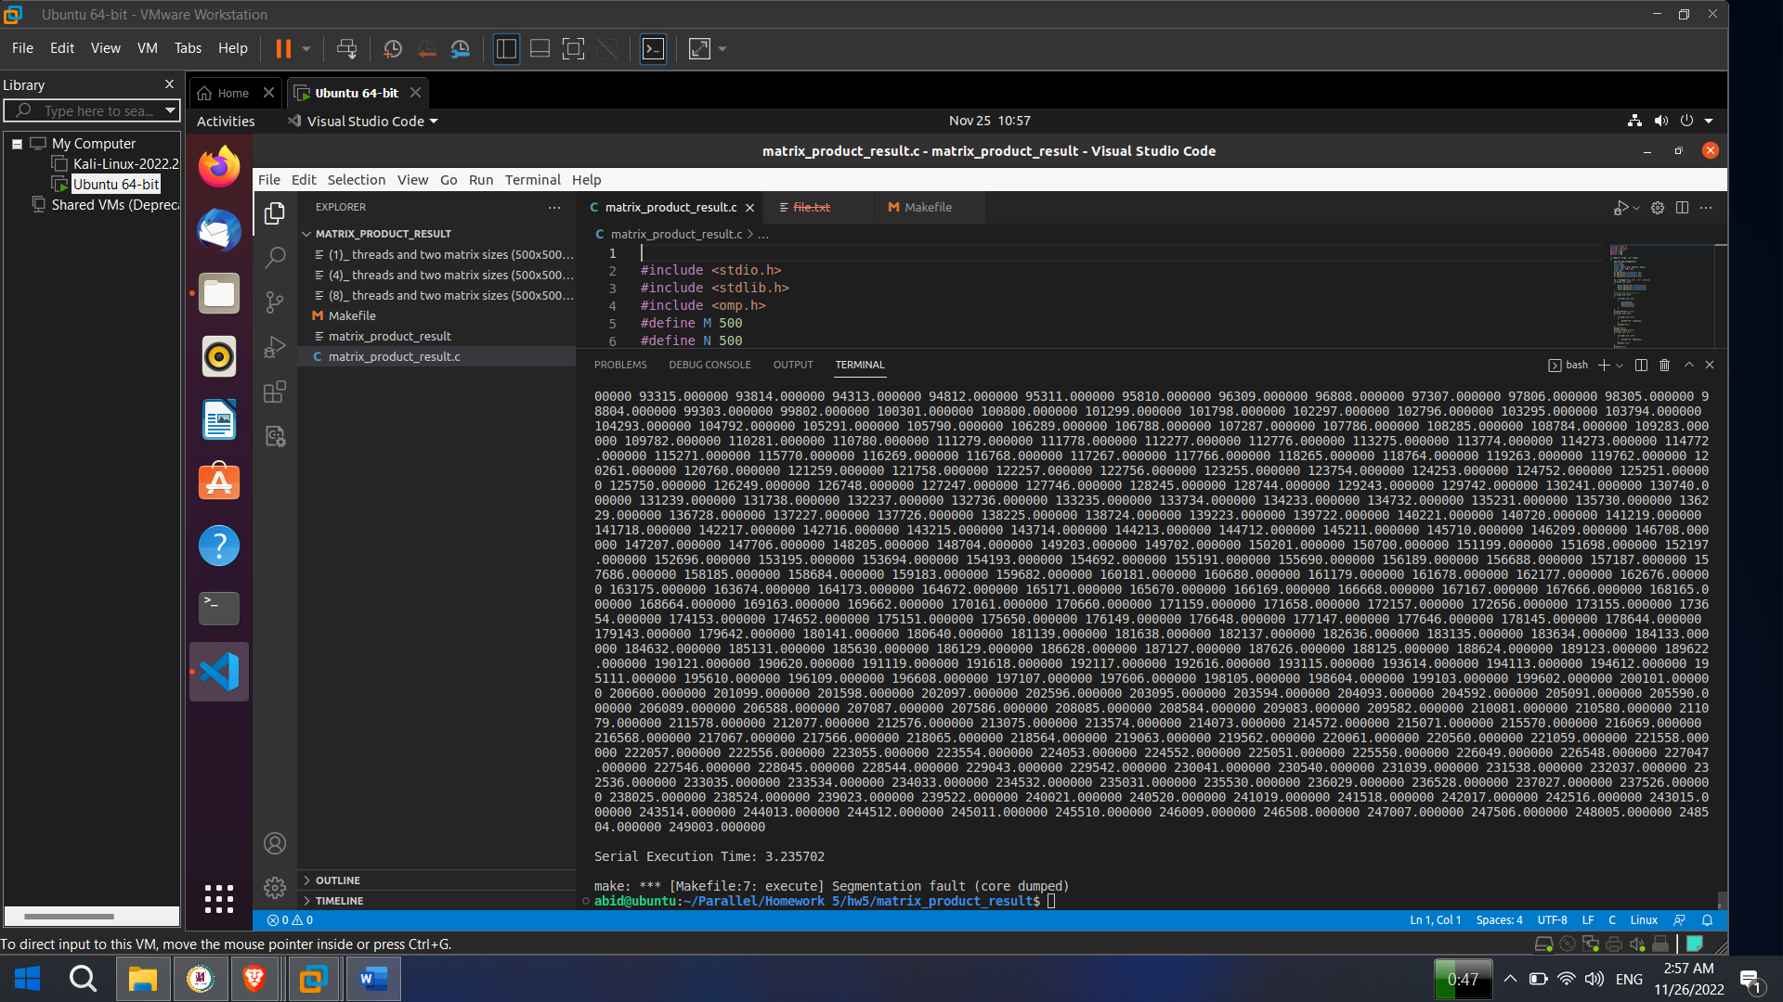

Fig : 8 threads and two matrix sizes 500x500

**16 threads and two matrix sizes 500x500**

#define M 500

#define N 500

omp_set_num_threads(16);



Serial Execution Time: 2.924644

Parallel Execution Time: Didn’t get due to segmentation fault. Don’t know the exact reason why the parallel part function couldn’t get the value. I think there is a limitation of processor and core that could be the reason.

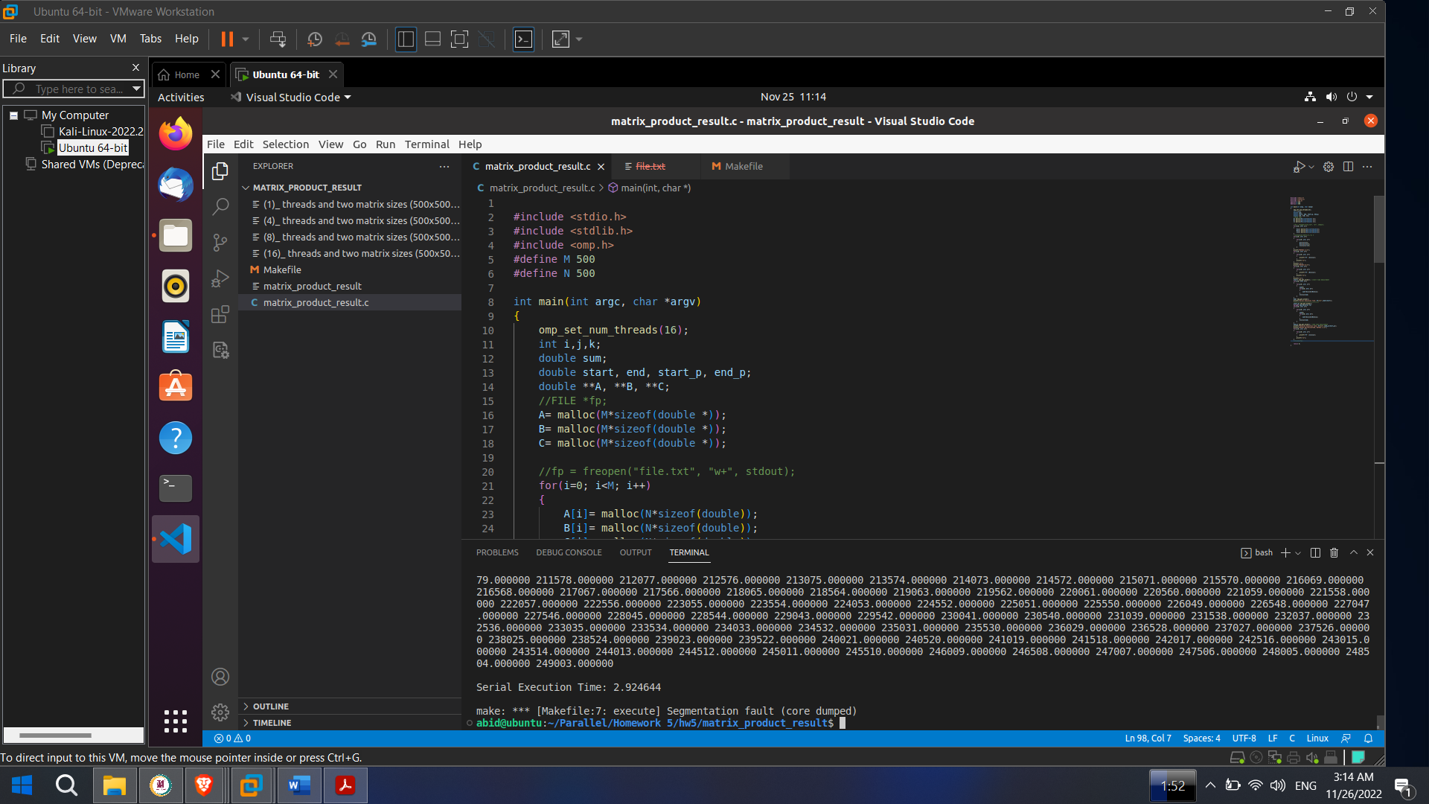

Fig : 16 threads and two matrix sizes 500x500

**1 threads and two matrix sizes 50x50**

#define M 50

#define N 50

omp_set_num_threads(1);



Serial Execution Time: 0.000455

Parallel Execution Time: 0.000538

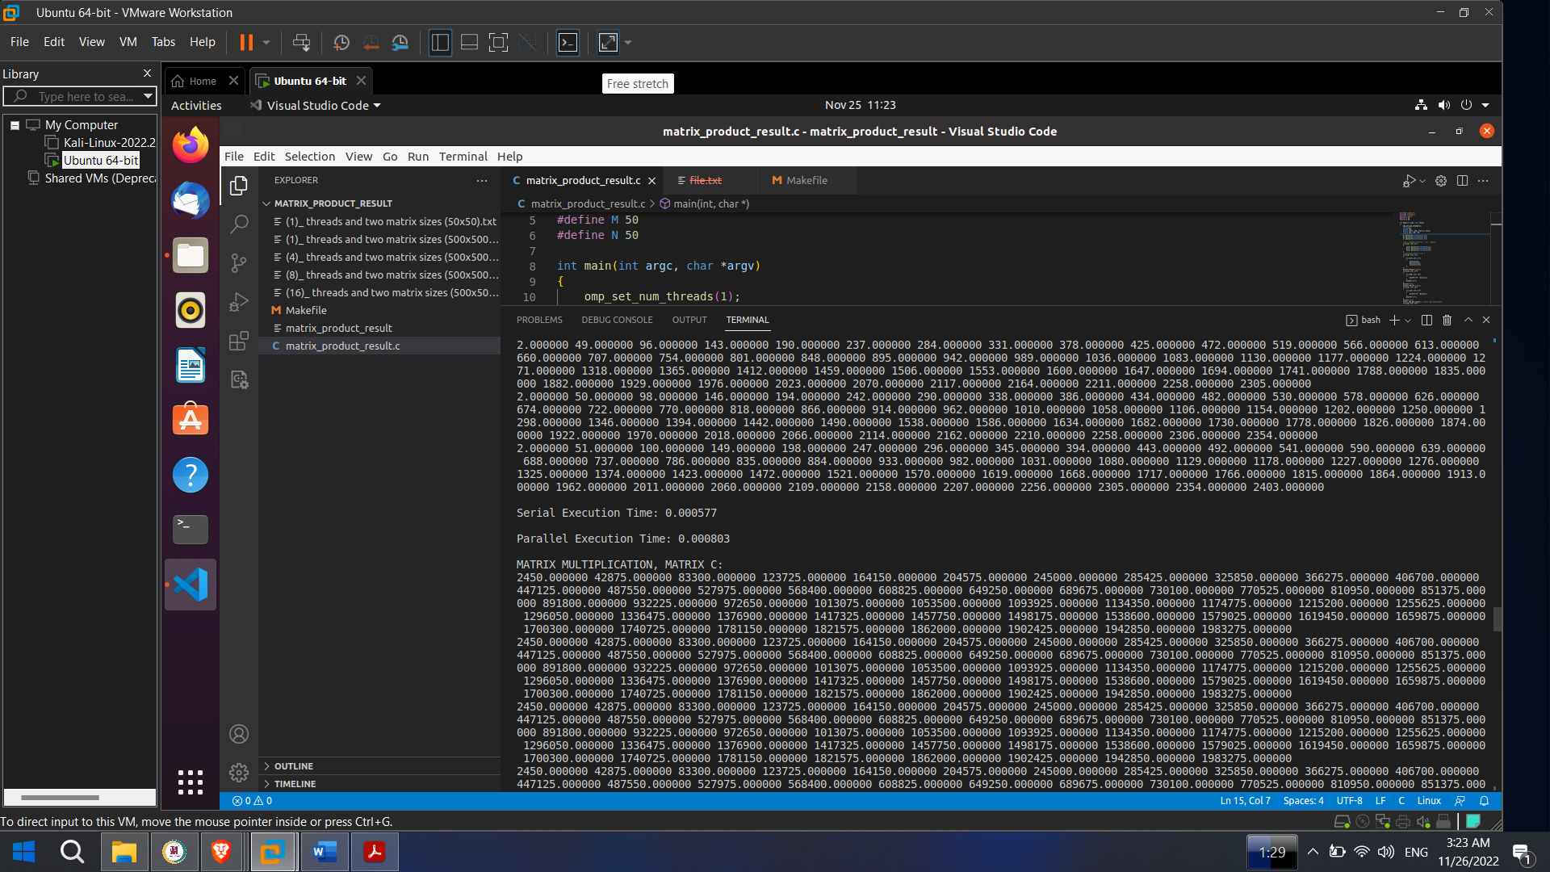

Fig : 1 threads and two matrix sizes 50x50

**4 threads and two matrix sizes 50x50**

#define M 50

#define N 50

omp_set_num_threads(4);



Serial Execution Time: 0.001381

Parallel Execution Time: Didn’t get due to segmentation fault. Don’t know the exact reason why the parallel part function couldn’t get the value. I think there is a limitation of processor and core that could be the reason.

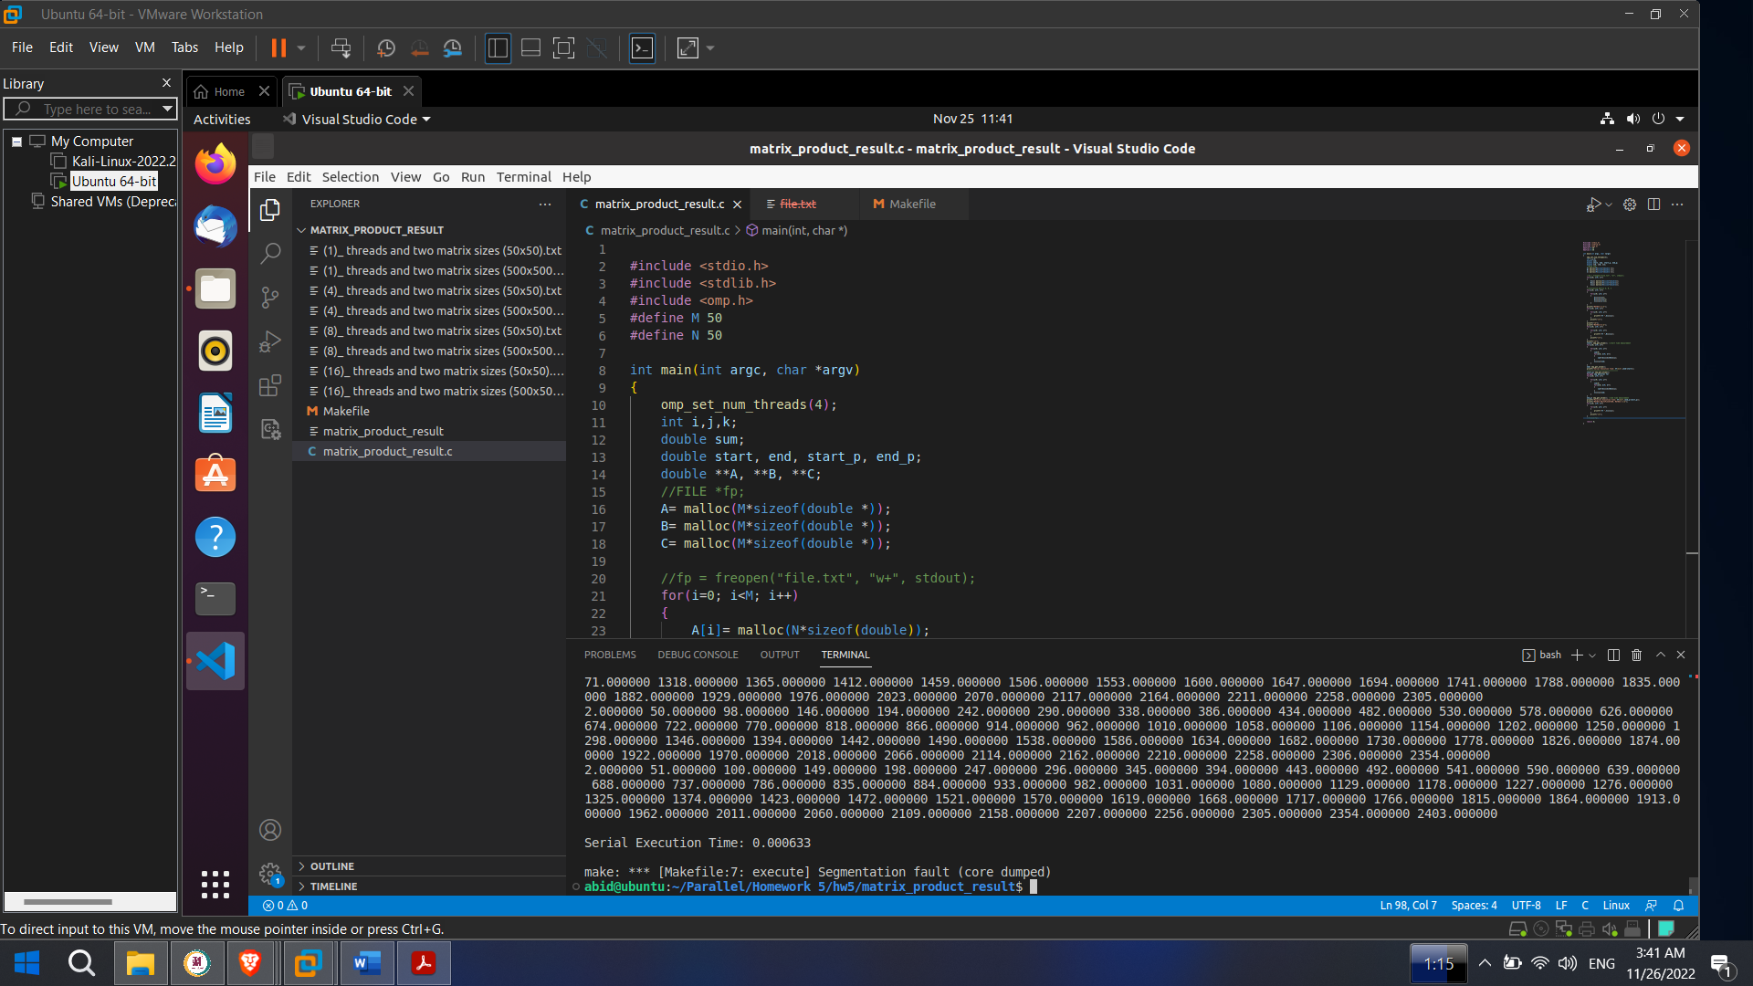

Fig : 4 threads and two matrix sizes 50x50

**8 threads and two matrix sizes 50x50**

#define M 50

#define N 50

omp_set_num_threads(8);



Serial Execution Time: 0.000539

Parallel Execution Time: Didn’t get due to segmentation fault. Don’t know the exact reason why the parallel part function couldn’t get the value. I think there is a limitation of processor and core that could be the reason.

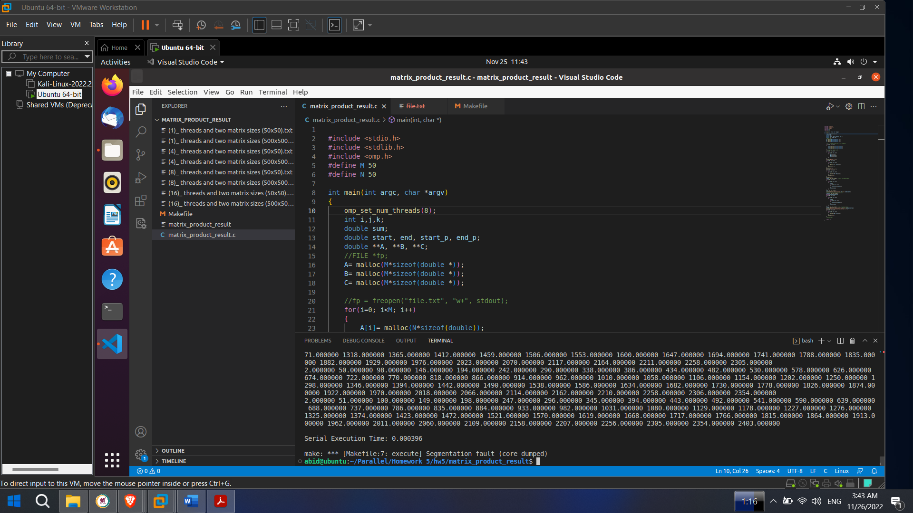

Fig : 8 threads and two matrix sizes 50x50

**16 threads and two matrix sizes 50x50**

#define M 50

#define N 50

omp_set_num_threads(16);



Serial Execution Time: 0.001175

Parallel Execution Time: Didn’t get due to segmentation fault. Don’t know the exact reason why the parallel part function couldn’t get the value. I think there is a limitation of processor and core that could be the reason.

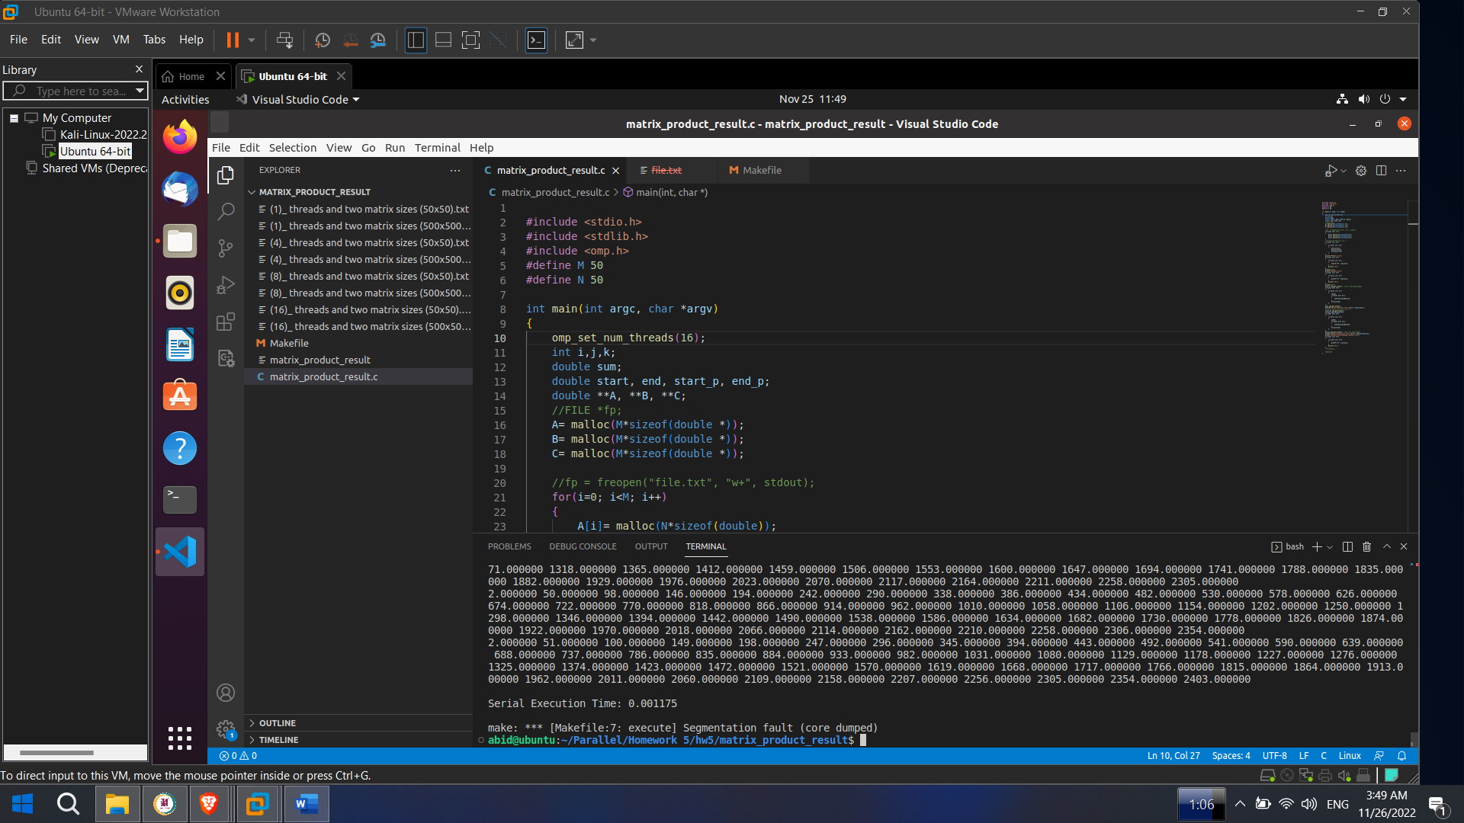

Fig : 16 threads and two matrix sizes 50x50